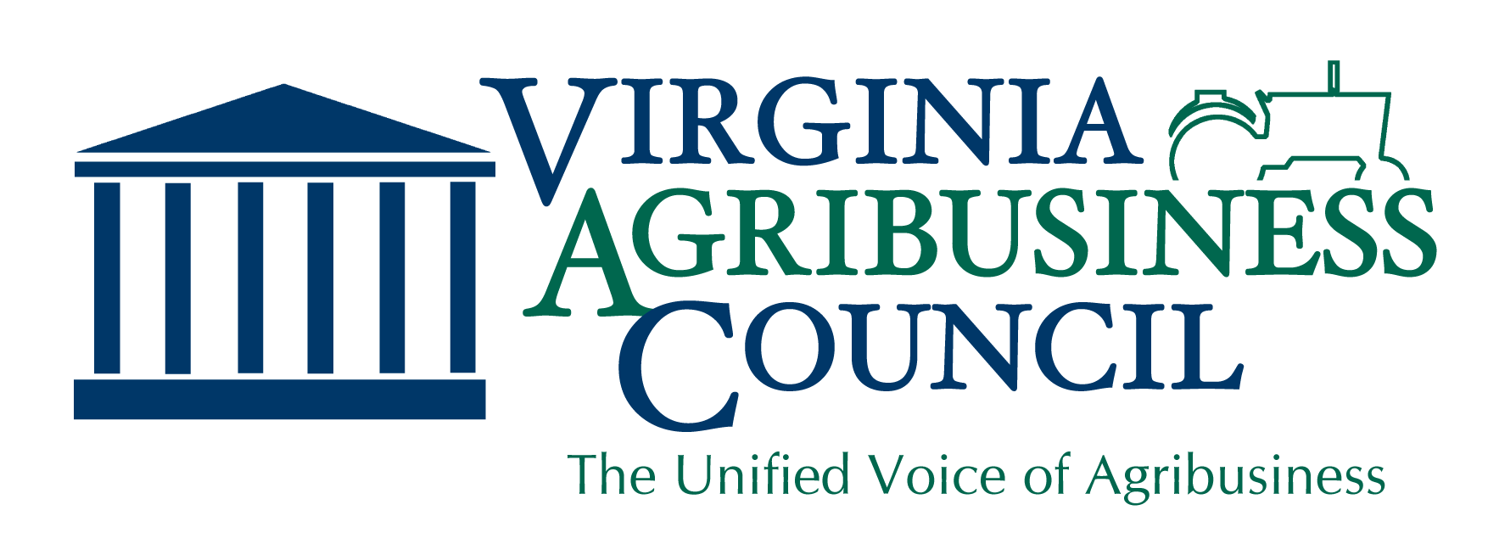

Timber Theft
Virginia’s Department of Forestry frequently receives reports of timber trespass each year. Timber resources are often a significant investment for rural landowners. Most people only sell timber once or twice in a lifetime and values can vary significantly. Since few people are experienced in timber harvesting, it’s easy for dishonest buyers to take advantage of unsuspecting landowners. Under current law, timber theft victims must overcome major hurdles to prove theft and recover compensation.
There are two main types of timber theft: timber trespass, where the logger crosses a property boundary and harvests trees that do not belong to his client; and timber contractual fraud, which occurs when a landowner contracts with a timber buyer but never receives full payment for all of the trees that become harvested.
The proposed bill would add language in the code to:
- Give the state forester explicit authority to assist in the investigation of reported timber theft.
- Create a criminal offense for a timber buyer who fails to pay a landowner for wood removed from their property within 60 days of request by the landowner.
- Create a criminal offense for a timber buyer who fails to provide the landowner with an accurate accounting of the wood delivered to a mill if the timber sale is based on a price per unit of timber sold.
- Change the current code to allow landowners more time to contract with a professional forester to estimate the value of trees removed in a case of timber trespass.
Why It’s Needed
For many years, industry leaders have been educating landowners in an effort to curb timber theft. However, bad actors continue to focus on first-time sellers and landowners who reside out of state and thus cannot keep a close eye on the harvest. These timber thieves have developed timber sale contracts that enable the buyer to avoid paying the landowner for all of the wood. Criminal prosecution is incredibly difficult, leaving landowners to pursue compensation in civil courts. More often than not, the costs of those court proceedings exceed the stolen compensation.
Our Position
The Virginia Agribusiness Council joins the Virginia Forestry Association, Virginia Logger’s Association, Virginia Forest Products Association, and the Virginia Farm Bureau Federation in support of granting the State Forester the authority to assist law enforcement agencies in the investigation and prosecution of dishonest timber buyers, who take advantage of unassuming forest landowners.

“We Represent Virginia Agribusiness with a Unified Voice”
For more information, please contact us at vac@va-agribusiness.org

