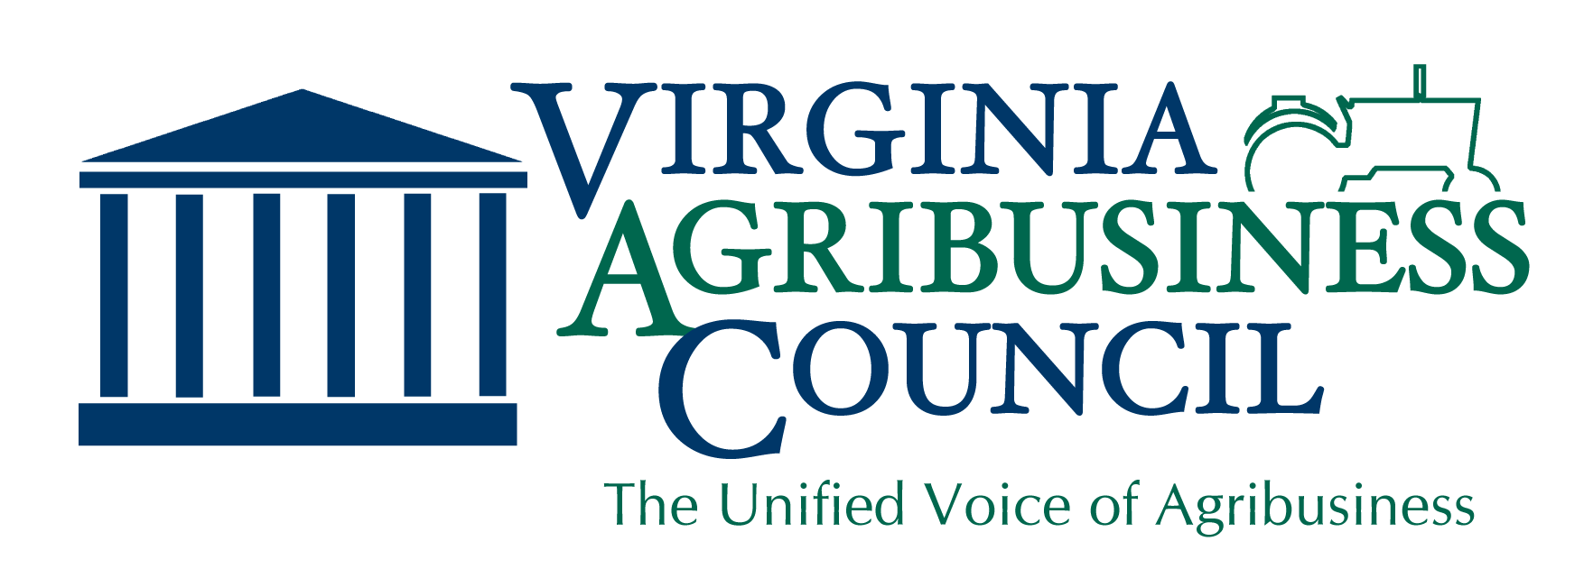

Industrial Hemp
The Virginia Agribusiness Council supports HB 1839 (Marshall) and SB 1692 (Ruff), which would conform Virginia law to federal law by updating the definitions of industrial hemp, marijuana, tetrahydrocannabinol (THC) to exclude industrial hemp that is grown, dealt, or processed in compliance with state or federal law. Regulated correctly, industrial hemp is marketed as a fiber, as a seed, or as a dual-purpose crop. This includes food and body products, clothing, auto parts, building materials, and other products.
VDACS has led the Virginia Industrial Hemp Research Program since the creation of the program as a result of legislation passed during the 2018 General Assembly session. Virginia’s higher education systems have also played a role in studying the uses of industrial hemp. HB 1839 and SB 1692 will allow a new economic opportunity for Virginia’s farmers to expand on these programs.
Why It’s Needed
The 2018 Farm Bill removed industrial hemp from the Controlled Substances List, sets up a regulatory framework for the commercial production of the crop and allows states to further regulatory authority over that production. However, the growth, dealing and processing of industrial hemp is still not permitted in Virginia. HB 1839 and SB 1692 permits the sale, dealing and processing of industrial hemp under Virginia law in conformity with federal definitions and gives VDACS the proper oversight authority to register and regulate every producer, dealer and processor.
Our Position
With proper regulatory, licensing, and law enforcement standards, the Council supports crop and seed research, market development, and the production of industrial hemp as an option for Virginia producers. The Council supports HB 1839 and SB 1692 as setting up the proper regulatory structure in Virginia to allow industrial hemp to grow as a cash crop.

“We Represent Virginia Agribusiness with a Unified Voice”
For more information, please contact us at vac@va-agribusiness.org

