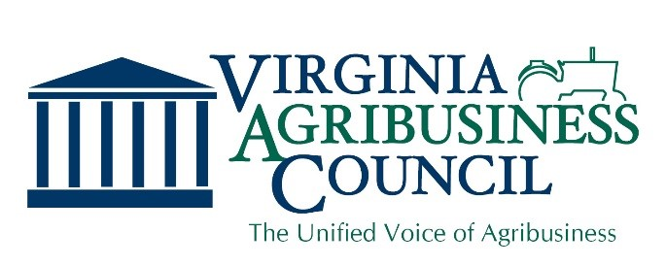

2018 Legislative Highlights

Legislative Victories

On your behalf, we were able to deliver a number of legislative victories before the Virginia General Assembly.

Agriculture Nuisance Bill (HB987 and SB567) - Passed
In response to lawsuits in other states, the agriculture community felt the need to preemptively add to the Right to Farm Act protections for agricultural operations. The bill prohibits a person from bringing a nuisance action against any agricultural operation the existence of which was known or reasonably knowable when that person's use or occupancy of his property began. The bill also prohibits anyone other than a person with an ownership interest in the affected property from bringing an action for private nuisance and sets out certain limitations on recovery for compensatory damages.
Land Use Assessment Legislation (HB 871) - Passed

VAC joined an effort to make it easier for new farmers to enter into agriculture businesses by shortening the amount of time a for real estate with no prior qualifying use to qualify for a land use assessment. The bill specifically provides that (i) land devoted to use includes land devoted to the sale of products made from plants and animals located on the property, (ii) land devoted to horticultural use includes land devoted to plants and the sale of products made from horticultural items, (iii) the agreement pursuant to soil and water conservation programs that qualifies land as devoted to agricultural or horticultural uses may be made with the Commonwealth, (iv) land designated for use value assessment shall not lose such designation solely because of its location in a newly created zoning district that was not requested by the property owner, and (v) if the state uniform standards for eligibility for real estate devoted to agricultural use or horticultural use require a minimum length of time of a specified use, then the use of other similar property by a lessee of the owner shall be included in calculating such time, and the Commissioner of Agriculture and Consumer Services shall include in the uniform standards a shorter length of time for real estate with no prior qualifying use, provided that the owner submits a written document of the owner's intent regarding use of the real estate containing elements set out in the uniform standards.

Virginia Grown Overweight Permit Over Bridges (SB73 and HB214) - Passed
This legislation provides that no vehicle issued an overweight permit (90K lbs.) for hauling Virginia-grown farm produce, with axle spacing of at least 42 ft., shall cross any bridge or culvert in the Commonwealth if the gross weight of such vehicle is greater than the amount posted for the bridge or culvert as its carrying capacity. Current law did not allow for the crossing of any bridges under this permit.
Agricultural Products Local Tax (SB 314 and HB 1022) - Passed

There have been issues in certain localities on which farm equipment is included in the definition of farm equipment. The bill clarifies what is included in "agricultural products," for the purposes of the classification of tangible personal property for taxation, as any livestock, aquaculture, poultry, horticultural, floricultural, viticulture, silvicultural, or other farm crops.

Virginia Cattle Assessment (SB 374)

Updates the cattle assessment which is an industry supported assessment to pool funds for collectively working together for marketing, promotion and education to help Virginia cattle producers. The cattle assessment would be $.50 per head sold in Virginia. A producer can choose to opt out if they do not wish to participate in the assessment. The Cattle Industry Board, comprised of 11 members appointed by the Governor, will administer the funds.

Industrial Hemp (SB247 and HB532)

The Senate version of the 2018 Farm Bill contains a provision reducing the prohibition around industrial hemp. The Virginia General Assembly passed a bill, supported by VAC, in anticipation of the provision being included in the final Farm Bill. This legislation authorizes the Commissioner of Agriculture and Consumer Services to undertake research through the establishment of a higher education industrial hemp research program, to be managed by institutions of higher education, and a Virginia industrial hemp research program. The bill classifies all participants in any research program as either growers or processors and replaces the current licensing requirement, which requires a police background check, with a registration requirement. The provisions of the bill would need an appropriation from the budget bill in order to be implemented.
Forest Products Definition to Include Rough Sawn Green Timber (HB 125) - Passed

The measure adds “rough sawn green timber” to the definition of forest products for the purpose of expanding the issuing of an overweight permit (90K lbs.) for hauling forest products.

Neonicotinoid Ban (HB 936) - Defeated

The bill would have authorized the Board of Agriculture and Consumer Services to restrict or prohibit the use of neonicotinoid insecticides (neonicotinoids) and would have prohibited the outdoor application of neonicotinoids on any property that is either owned or maintained by the Commonwealth or zoned for residential use. After meeting with VAC and other stakeholders, the patron agreed to strike the bill.

Bill Limiting Above Ground Storage Tanks (HB 1136) - Defeated

The bill would have authorized localities to adopt an ordinance that makes it illegal for any person to construct, maintain, or use any aboveground chemical storage tank (ACST) having a capacity of 250 gallons or more without obtaining a permit from the local fire official. The bill was left in committee.

State Budget Related Items

The Council was successful in preserving funding for our agriculture and forestry priorities.

Agricultural BMPs: The General Assembly largely adhered to what was in the Governor’s proposed budget. This included $17.0 million for the Ag BMP cost-share program and $2.4 million for technical assistance. Ag BMP cost-share also will continue getting funds from recordation fees, which amounts to approximately $8.0 million annually. The passed budget also awarded $2.6 million in FY19 and FY20 from un-refunded marine fuels sales taxes to help stabilize Ag BMP funding.
Reforestation of Timberlands Incentives Program: The General Assembly included over $1.9 million each year for the Reforestation of Timberlands Program to be used for private landowners involved in forestry.
Horse Racing: The budget included nearly $1.7 million each year for the Virginia Racing Commission to carry out the regulation of the horse racing industry. In the event revenues exceed those needed by the Commission, the budget allows for grants up to $700,000 for furthering the horse racing industry including horse breeding.
Agricultural Marketing: The passed budget included $43 million for industry promotion and marketing including over $14 million for agricultural commodity boards and nearly $2 million for agribusiness development services and farmland preservation.

