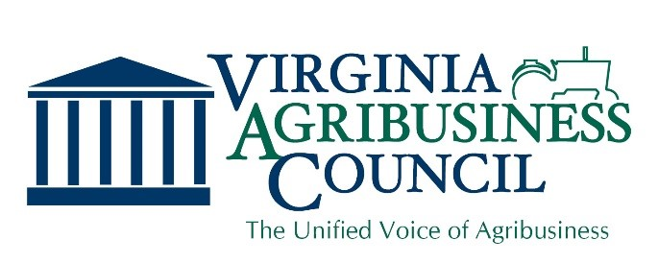

Interstate 81

Interstate 81 has become a critical transportation channel for Virginia and the east coast. Investment in improvements for Interstate 81 is needed, and we believe the costs to improve this vital interstate should be distributed equitably across all who use it. The Virginia Agribusiness Council opposes funding options that do not equitably and fairly spread the cost of improvements.

Funding Options

$2.04 billion in improvements are already funded in the current SYIP adopted by the Commonwealth Transportation Board (CTB). An additional $2 billion in capital improvements are included in its most recent proposal, with funding sources that include two regional taxes (fuel and retail) and /or variable-rate tolls. Depending on which options are selected by the General Assembly, these could generate between $130 million and $204 million annually. Regional fuel and retail taxes would be assessed by Planning District Commissions 3-7. A $1.5 billion 35-year bond issue would cover the remaining sum.

Variable-rate tolls, which differentiate based on day or nighttime travel, cannot be accurately projected because I-81 has never been tolled and thus no data can exist that shows how variable-rate tolls would affect commuter and trucking behavior on this particular road. And as we have seen in other states, tolls often do not achieve their original purpose and end up costing taxpayers between 12% and 25% of the amount tolled, which goes directly to the companies who set up the tolling infrastructure.

Tolling Impact on Agriculture

The CTB proposal would place variable tolls per trip on commercial vehicles. This represents millions of dollars in increased transportation costs for the agricultural and forestry industries. Tolls could especially harm certain producers, such as dairies, that are unable to pass along this increased cost in the form of higher prices for their products. Shipping costs via truck are charged by the mile, so the decrease in delays from the highway improvements will not allow shippers to recoup those increased costs.

Our Position

The Virginia Agribusiness Council opposes onerous tolls placed solely on commercial truck traffic due to the increased cost, competitive disadvantage, and increased diversion on parallel, rural roads. In addition, the Council opposes funding for improvements to Interstate 81 that are not fairly distributed across all users.

“We Represent Virginia Agribusiness with a Unified Voice”
For more information, please contact us at vac@va-agribusiness.org

