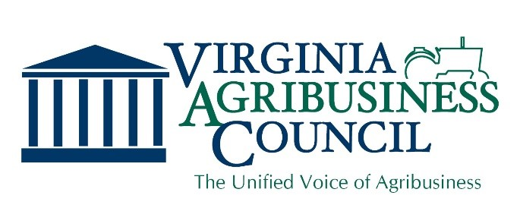

Rural Broadband

Rural Virginians are in danger of being left out of our 21st century economy. Some Virginia localities as well as private stakeholders have been working hard to expand broadband access to rural areas, but more work is needed to ensure reliable, high-speed internet reaches all corners of the state. In order for Virginia to remain competitive in a fast-changing, global economy, its citizens, governments, and businesses must be able to access reliable, high-speed broadband throughout the Commonwealth.

Achieving the Commonwealth’s broadband goals requires extensive work and investment. The Governor’s budget includes a $46 million investment in the first year and $50 million dollars in the second year to be used for grants to further this important work. High-speed internet can be delivered through fiber, coaxial, mobile or fixed wireless, satellite, or any combination thereof. The missing component is adequate funding to install the needed infrastructure to make this a reality.

Why It’s Needed

Rural Virginians are struggling to keep up with fast-paced advances in technology, most of which occur and achieve affordable scale in highly populated urban areas. In the agriculture industry, producers face tremendous hurdles and risks, and without needed business capabilities like high-speed internet the cost of doing business grows rapidly and unsustainably, causing Virginia Agribusinesses to fall behind.

Precision Ag: In order to implement precision ag practices and operations, Virginia farmers and agribusinesses need reliable high-speed internet to meet the demands of this quickly-moving industry transition.

Agritourism: Virginia’s emerging agritourism industry requires reliable high-speed internet in order to develop sustainable operations. From weather forecasts to accurate and affordable data storage, these businesses suffer without a reliable connection.

Our Position

A number of key stakeholders have come together to support Governor Northam’s broadband initiative. The Virginia Agribusiness Council is pleased to support efforts to expand funding for affordable broadband and high speed internet access to the entire Commonwealth for the purposes of expanding business opportunities and precision agribusiness practices in rural Virginia. We believe this funding should be spread equitably among rural regions and providers.

“We Represent Virginia Agribusiness with a Unified Voice”
For more information, please contact us at vac@va-agribusiness.org

